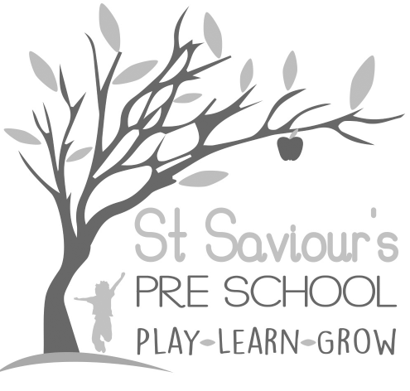
1:11 LOOKED AFTER, ADOPTED and CHILDREN IN NEED

Written by: Claire Toms and Tina Alder Date: 1.09.22 – reviewed 31.9.25

Policy Statement
We are committed to providing the best possible care for all children registered at St Saviour’s Pre-school and Nursery.
The designated person for Looked After, Adopted and Children in Need is Tina Alder.
We recognise our duty under the Children Act 1989 to identify and support children who may be assessed by the local authority as “children in need,” i.e., those who require extra support services to achieve or maintain a reasonable standard of health or development, are at risk of significant harm without such services, or are living with disability.
In line with the 2025 EYFS, we ensure that all children, including those who are looked after, adopted, or assessed as children in need, receive effective safeguarding, individualised support, and inclusive provision.

Procedures
In the case of Looked After, Adopted or Children in Need, the following procedures are in place to ensure their specific needs are met:
- Children and their carers are welcomed into the group and the induction programme in place for all new children is followed. This includes allocating a key person for each child, who will work closely with the family and professionals.
- When necessary, we will meet with all parties involved such as carers, health visitors, social workers, and specialist professionals for Looked After, Adopted and Children in Need as appropriate, liaising to build a picture of the care appropriate to the child. Thereafter, meetings will then take place regularly with all parties involved.
- A Personal Education Plan (PEP) may be written and reviewed at least every six months, with all the accompanying documentation about progress. For children in need, an agreed support plan may be developed in partnership with the local authority and reviewed regularly to ensure the child’s needs are met.
- We work in partnership with parents, carers and professionals to provide additional support, interventions and reasonable adjustments, ensuring that children with disabilities or those at risk of neglect receive tailored care and education.
- Safeguarding remains central. Where there are concerns that a child’s health, safety or development is at risk, we will follow our Safeguarding and Child Protection Policy, making timely referrals to children’s social care in line with EYFS 2025 requirements.
- Records relating to looked after, adopted and children in need will be stored securely and shared only with those who have a professional need to know, in line with confidentiality and data protection requirements.

